Q. 1. What is different in compiler and interpreter? What does it mean java is platform independent? (2 points)
Complier: scans the entirety of the code and translates the whole program into machine code at once. The complier takes longer to source the code but the overall process is much faster than an interpreter. Eg C, C++
Interpreter: translates just one statement of the program at a time into machine code. It keeps translating the code until an error is found unlike a complier that scans the complete code. This makes an interpreter much easier to identify an error. Eg Ruby,Python
The meaning of java is platform independent is that it can run on all operating systems. It is readable to humans as it may include words,phrases that the machine wont understand.

Q. 2. Define two variables x and y. Use input function to get the integer inputs, add them and print the output. Your output should look like the following. (3 points).
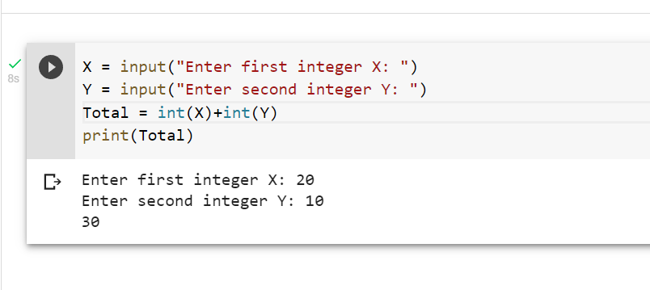

Q. 3. Test the output of the following code and explain str1[1:4] str1[:5], str1[4:]? (2 points) str1 = "Hello World" print(str1[1:4], str1[:5], str1[4:])

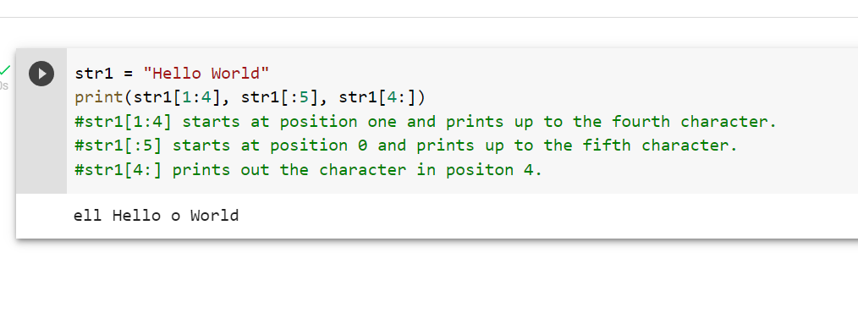
Q. 4. Explain the following string functions with examples and paste the screenshot your code and output. (3 points)
a. count ()
b. find()
c. index(

